Java Garbage colection

Java garbage collection is generational and is based on assumption that most objects die young (not referenced anymore shortly after their creation and as such can be destroyed safely). Most developers used to believe that objects creation in Java is slow and instantinot hold true: the objects creation in Javaation of the new objects should be avoided as much as possible. In fact, it does is quite cheap and fast. What is expensive though is an unnecessary creation of long-lived objects which eventually may fill up
old generation and cause stop-the-world garbage collection (advaned java book)

Java Virtual Machine

The Java Virtual Machine (JVM) is an abstract computing machine. The JVM is a program that looks like a machine to the programs written to execute in it.
The Java virtual machine knows nothing of the Java programming language, only of a particular binary format, the class file format. A class file contains Java virtual machine instructions (or bytecodes) and a symbol table, as well as other ancillary information.

Hotspot JVM Architecture
The main components of the JVM include the classloader, the runtime data areas, and the execution engine.
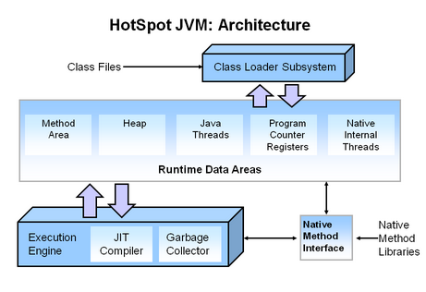
There are three components of the JVM that are focused on when tuning performance.
The heap is where your object data is stored. This area is then managed by the garbage collector selected at startup. Most tuning options relate to sizing the heap and choosing the most appropriate garbage collector for your situation. The JIT compiler also has a big impact on performance but rarely requires tuning with the newer versions of the JVM.

Typically, when tuning a Java application, the focus is on one of two main goals: responsiveness or throughput .
Responsiveness refers to how quickly an application or system responds with a requested piece of data. Examples include:
- How quickly a desktop UI responds to an event
- How fast a website returns a page
- How fast a database query is returned
Throughput focuses on maximizing the amount of work by an application in a specific period of time
The number of transactions completed in a given time.
- The number of jobs that a batch program can complete in an hour.
- The number of database queries that can be completed in an hour.

What is Garbage Collection

Is the process of looking at heap memory, identifying which objects are in use and which are not, and deleting the unused objects. An in use object, or a referenced object, means that some part of your program still maintains a pointer to that object. An unused object, or unreferenced object, is no longer referenced by any part of your program.
The first step in the process is called marking. This is where the garbage collector identifies which pieces of memory are in use and which are not. his can be a very time consuming process if all objects in a system must be scanned.
Normal deletion removes unreferenced objects leaving referenced objects and pointers to free space. To further improve performance, in addition to deleting unreferenced objects, it will also compact the remaining referenced objects.
As more and more objects are allocated, the list of objects grows and grows leading to longer and longer garbage collection time. However, empirical analysis of applications has shown that most objects are short lived
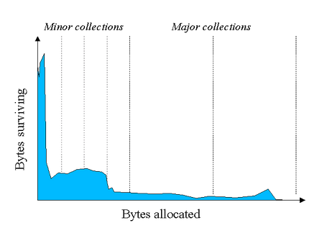
As you can see, fewer and fewer objects remain allocated over time. In fact most objects have a very short life as shown by the higher values on the left side of the graph
.
The heap is broken up into smaller parts or generations. The heap parts are: Young Generation, Old or Tenured Generation, and Permanent Generation
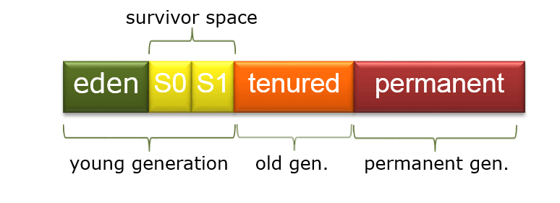
The Young Generation is where all new objects are allocated and aged. When the young generation fills up, this causes a minor garbage collection. Minor collections can be optimized assuming a high object mortality rate. A young generation full of dead objects is collected very quickly.
Some surviving objects are aged and eventually move to the old generation.
Eventually the old generation needs to be collected. This event is called a major garbage collection.
All minor and major garbage collections are "Stop the World" events. This means that all application threads are stopped until the operation completes.
The Permanent generation contains metadata required by the JVM to describe the classes

The Visual VM program is included with the JDK and allows developers to monitor various aspects of a running JVM

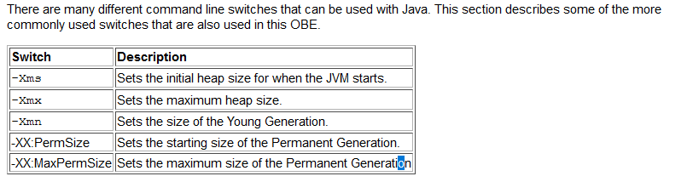
TODO BOOK Java-Performance https://www.amazon.com/Java-Performance-Charlie-Hunt/dp/0137142528/ref=sr_1_1
for java 8
-> https://www.amazon.com/Java-Performance-Definitive-Guide-Getting

HotSpot has four garbage collectors:
- Serial: All garbage collection events are conducted serially in one thread. Compaction is executed after each garbage collection.
- Parallel: Multiple threads are used for minor garbage collection. A single thread is used for major garbage collection and Old Generation compaction. Alternatively, the Parallel Old variant uses multiple threads for major garbage collection and Old Generation compaction.
- CMS (Concurrent Mark Sweep): Multiple threads are used for minor garbage collection using the same algorithm as Parallel. Major garbage collection is multi-threaded, like Parallel Old, but CMS runs concurrently alongside application processes to minimize “stop the world” events (i.e. when the garbage collector running stops the application). No compaction is performed.
- G1 (Garbage First): The newest garbage collector is intended as a replacement for CMS. It is parallel and concurrent like CMS, but it works quite differently under the hood compared to the older garbage collectors.
- TODO need to be updated to java 8, 9, 11read (https://medium.com/@hasithalgamge/seven-types-of-java-garbage-collectors-6297a1418e82).

Ways to make an object eligible for GC
- Even though the programmer is not responsible to destroy useless objects but it is highly recommended to make an object unreachable(thus eligible for GC) if it is no longer required.
- There are generally four different ways to make an object eligible for garbage collection.
    - Nullifying the reference variable
    - Re-assigning the reference variable
    - Object created inside method
    - Island of Isolation

Object created inside method
When a method is called it goes inside the stack frame. When the method is popped from the stack, all its members dies and if some objects were created inside it then these objects becomes unreachable. If a method returns the object created inside it and we store this object reference by using a reference-type variable than it is no longer eligible for garbage collection because object it have reference that exist.

When reference id of one object is referenced to reference id of some other object then the previous object has no any longer reference to it and becomes unreachable and thus becomes eligible for garbage collection

Nullifying the reference variable : When all the reference variables of an object are changed to NULL

stao: https://www.dynatrace.com/resources/ebooks/javabook/how-garbage-collection-works/

How Garbage Collection Works

Ironically, Java garbage collection seems to work too well, creating and removing too many objects. Most memory-management issues are solved, but often at the cost of creating serious performance problems. Making garbage collection adaptable to all kinds of situations has led to a complex and hard-to-optimize system. To wrap your head around garbage collection, you need first to understand how memory management works in a Java Virtual Machine (JVM).
Many people think garbage collection collects and discards dead objects. In reality, Java garbage collection is doing the opposite! Live objects are tracked and everything else designated garbage

As we've seen (https://www.dynatrace.com/resources/ebooks/javabook/how-garbage-collection-works/), the performance of the garbage collector is not determined by the number of dead objects, but rather by the number of live ones. The more objects die, the faster garbage collection is. If every object in the heap were to be garbage-collected, the GC cycle would be nearly instantaneous. Additionally, the garbage collector must suspend the execution of the application to ensure the integrity of the object trees. The more live objects are found, the longer the suspension, which has a direct impact on response time and throughput

How to Avoid Java Memory Leaks

From: https://stackify.com/java-memory-leaks-solutions/
Use reference objects to avoid memory leaks
Raimond Reichert at JavaWorld writes that you can use reference objects to get rid of memory leaks.
Using the java.lang.ref package, you can work with the garbage collector in your program. This allows you to avoid directly referencing objects, but use special reference objects that are easily cleared by the garbage collector

There is only one way to make GC faster: ensure that as few objects as possible are reachable during the garbage collection. The fewer objects that are alive, the less there is to be marked. This is the rationale behind the generational heap (Objects are ussually created in the young area. Once an object has survived a couple of GC cycles it is tenured to the old generation. )

The young generation must be big enough to ensure that all temporary objects die there. Since the number of temporary objects in most applications depends on the current application load, the optimal young generation size is load-related. Therefore, sizing the young generation, known as generation-sizing, is the key to achieving peak load

Java Memory managemt tools
https://stackify.com/java-profilers-3-types/
https://stackify.com/java-performance-tools-8-types-tools-need-know/

Since Java 5, the standard JDK monitoring tool has been JConsole. The Oracle JDK also includes jStat, which enables the monitoring of memory usage and garbage-collector activity from the console, and Java VisualVM (or jvisualvm), which provides rudimentary memory analyses and a profiler. The Oracle JRockit JDK includes JRockit Mission Control and the verbose:gc flag of the JVM. Each JVM vendor includes its own monitoring tools, and there are numerous commercial tools available that offer additional functionality.

TODO Članak: Whay immutable classes can be good idea, from perspective of GC a (Java)
https://stackoverflow.com/questions/35384393/how-do-immutable-objects-help-decrease-overhead-due-to-garbage-collection

resources;
https://www.dynatrace.com/resources/ebooks/javabook/reduce-garbage-collection-pause-time/
https://alibabatech.medium.com/how-does-garbage-collection-work-in-java-cf4e31343e43
https://medium.com/@hasithalgamge/seven-types-of-java-garbage-collectors-6297a1418e82
https://www.javatpoint.com/Garbage-Collection
https://en.wikipedia.org/wiki/Garbage_collection_(computer_science)
https://beginnersbook.com/2013/04/java-garbage-collection/
https://www.infoworld.com/article/2078645/jvm-performance-optimization-part-3-garbage-collection.html
https://plumbr.io/java-garbage-collection-handbook
https://www.eginnovations.com/blog/what-is-garbage-collection-java/
https://www.infoq.com/articles/understand-classic-java-garbage-collection/
https://www.guru99.com/java-garbage-collection.html
https://gceasy.io/
https://sematext.com/blog/java-garbage-collection/
https://codeburst.io/advanced-concepts-of-java-garbage-collection-325c56c77829
https://www.cubrid.org/blog/3826410
https://devblogs.microsoft.com/java/how-to-tell-time-in-javas-garbage-collection/
https://developer.amd.com/4-easy-ways-to-do-java-garbage-collection-tuning/
https://www.eclipsecon.org/2020/sessions/demystifying-garbage-collection-java
https://www.softwaretestinghelp.com/garbage-collection-in-java/
https://ieeexplore.ieee.org/abstract/document/8756844
https://dzone.com/articles/choosing-the-best-garbage-collection-algorithm-for
https://www.artima.com/underthehood/gc.html
https://www.toptal.com/java/hunting-memory-leaks-in-java
https://www.infoworld.com/article/2077581/java-tip-79--interact-with-garbage-collector-to-avoid-memory-leaks.html
https://www.infoworld.com/article/2077581/java-tip-79--interact-with-garbage-collector-to-avoid-memory-leaks.html
https://www.agiledeveloper.com/articles/MemoryLeak092002.pdf

